

**Name = Muhammad Waleed Sattar**

**SAP-ID = 55700**

**Section = BS SE 3-2**

**Subject = Data Structures**

**Lab Task 03:**

**Question 1:**

**Code & Output:**

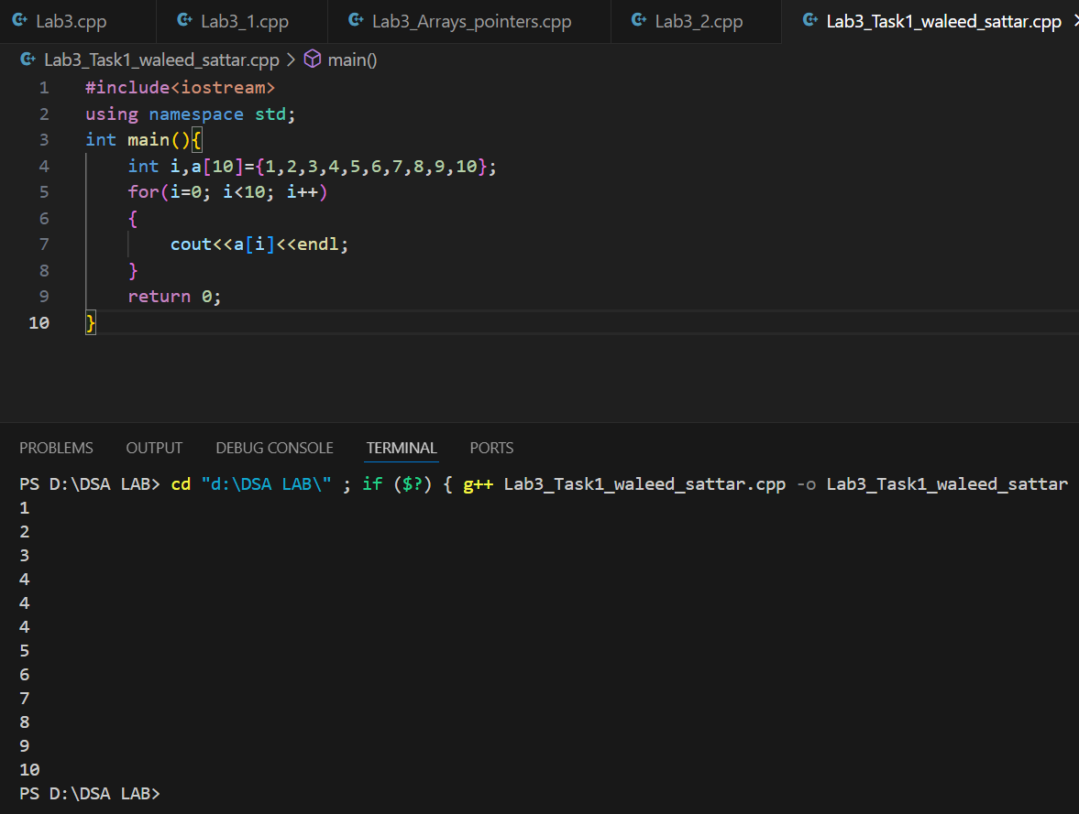

**Question 2:**

**Code & Output:**

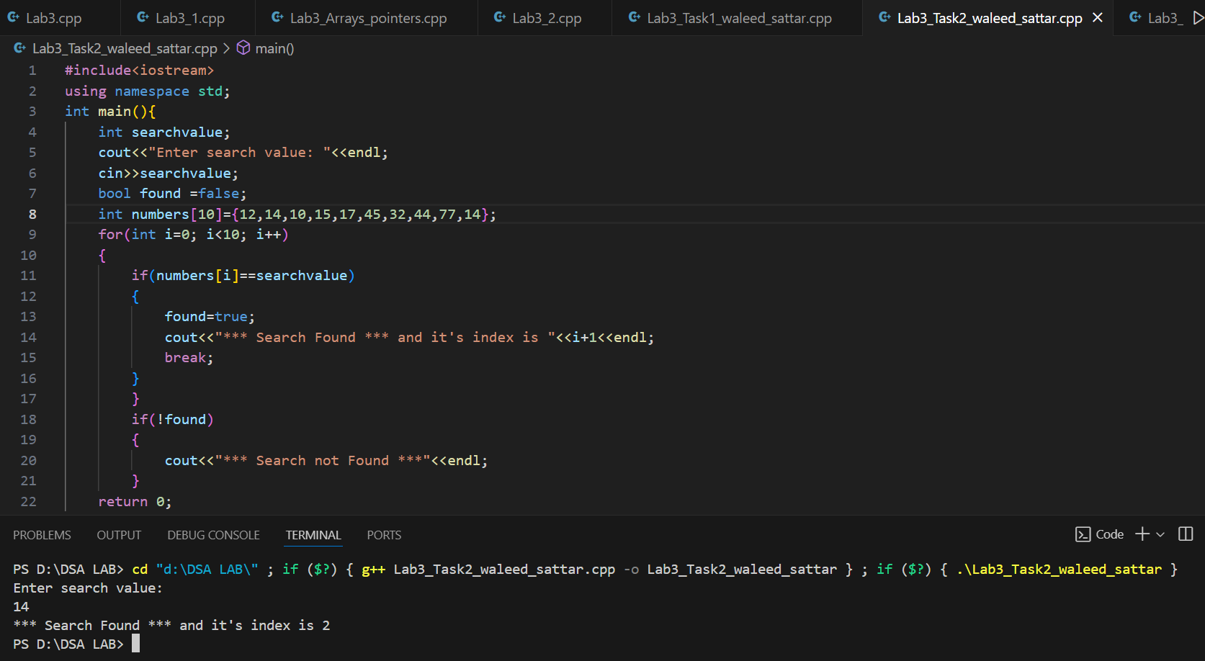

**Question 03:**

**Code & Output:**

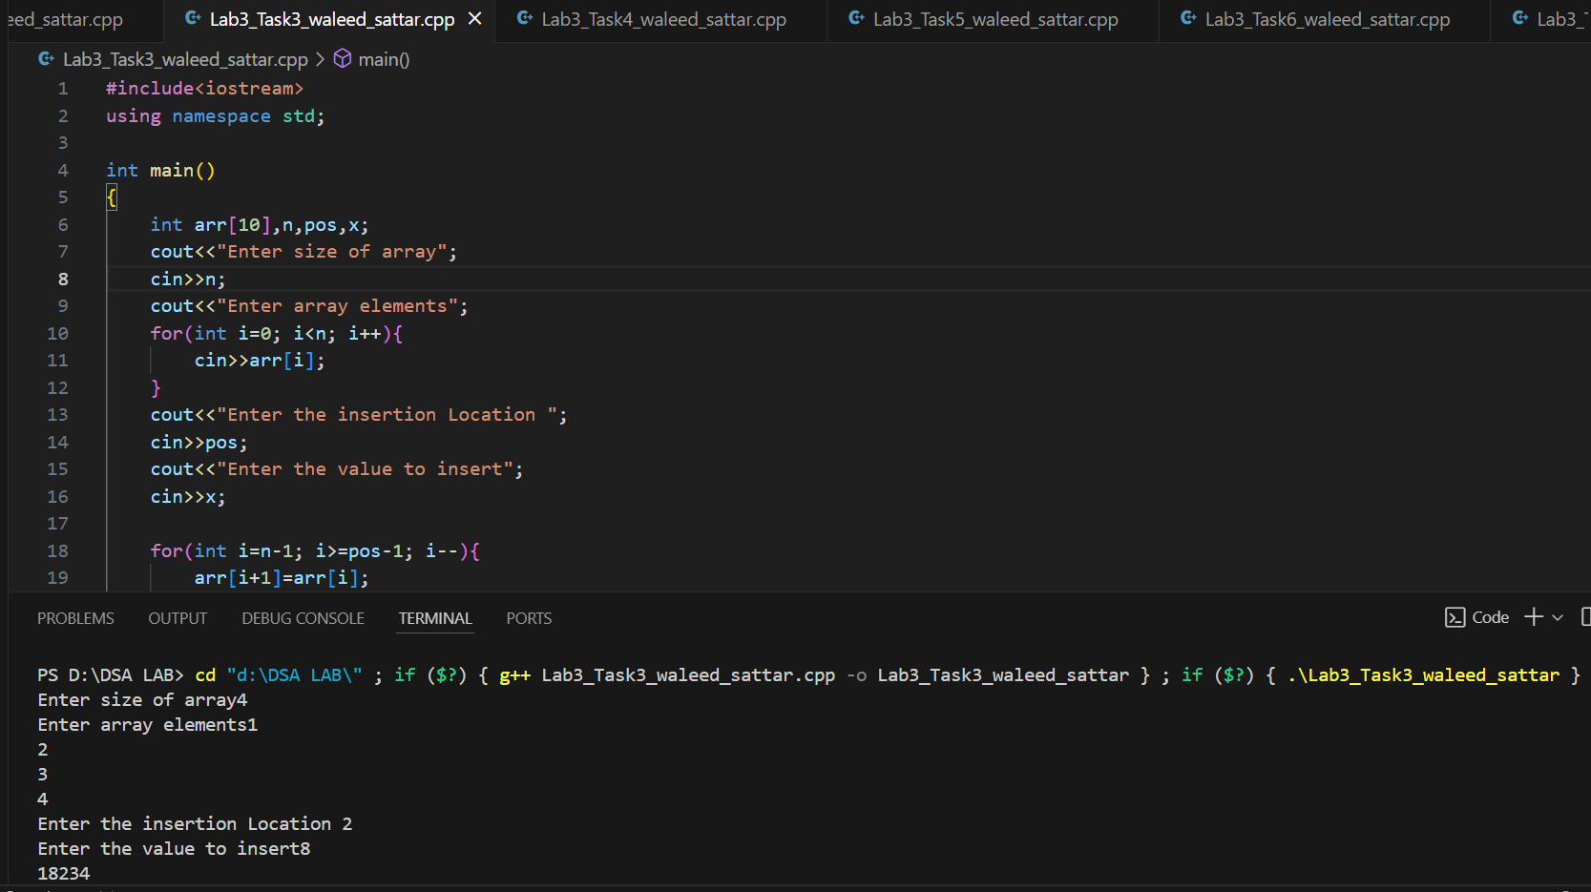

**Question 04:**

**Code &Output:**

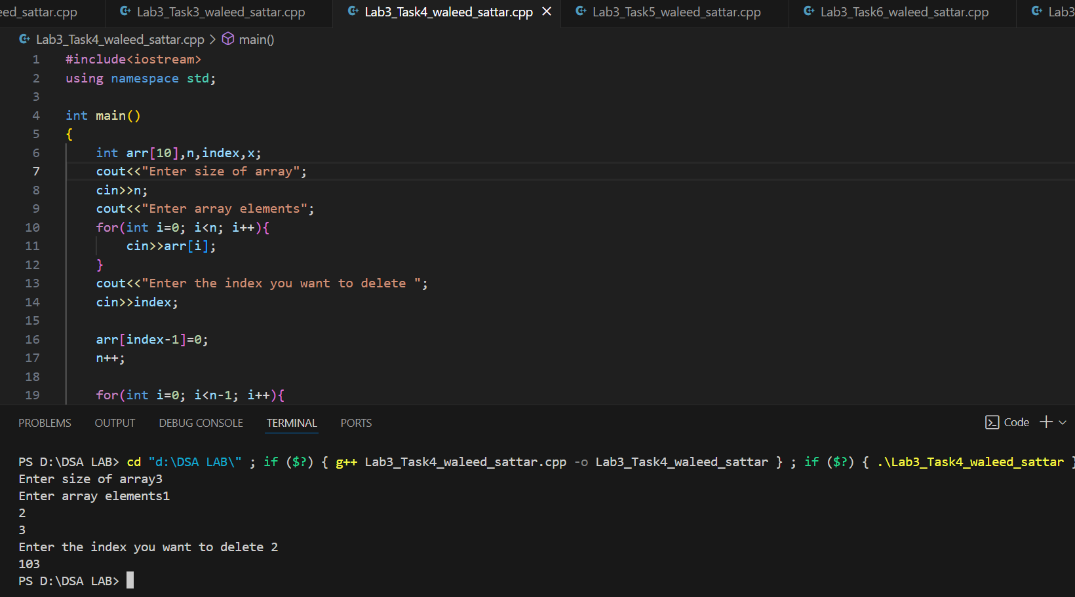

**Question 05:**

**Code & Output:**

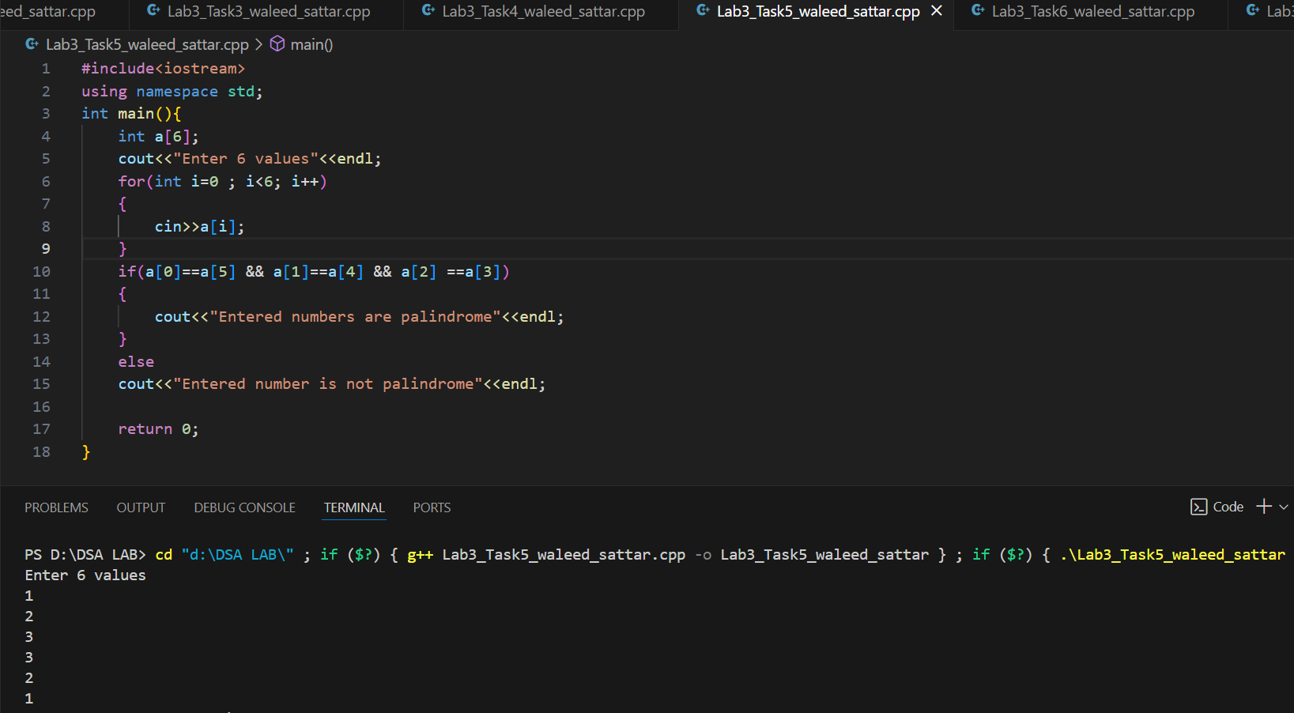

**Question 06:**

**Code & Output:**

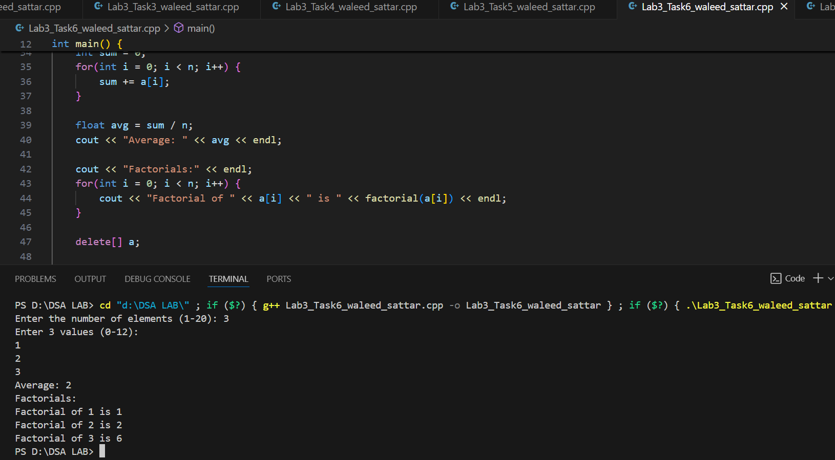

**Question 07:**

**Code & Output:**

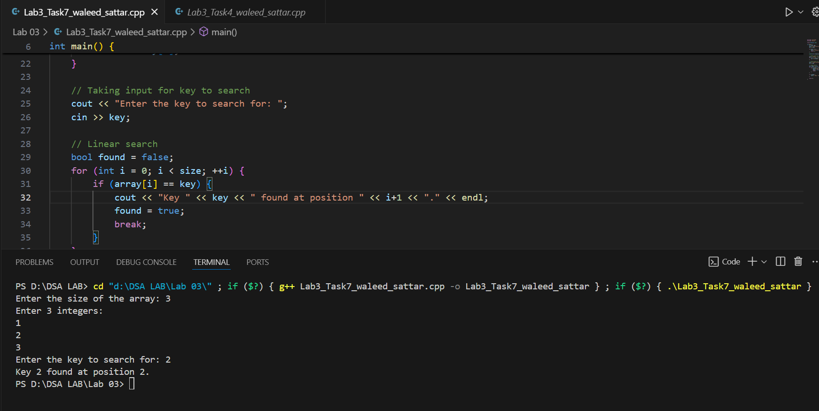

**Question 08:**

**Code & Output:**

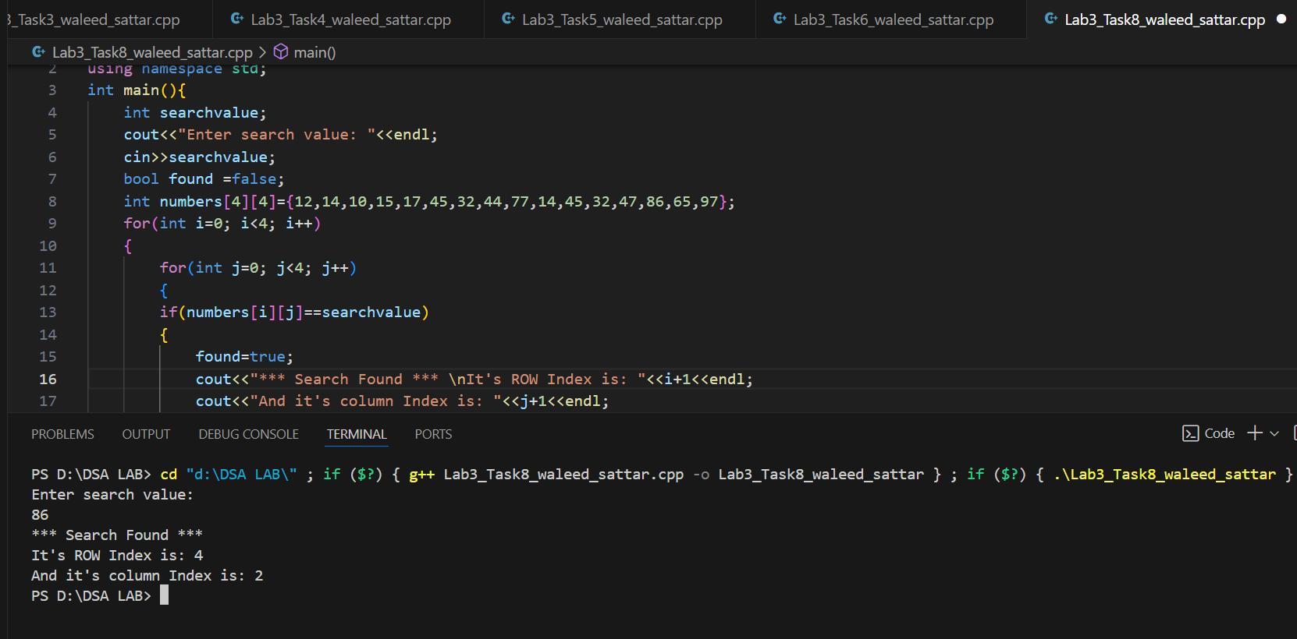

**Question 09:**

**Code & Output:** 